Works by Robert Porreca at the Bryn Du Mansion
Contact Bryn Du at 740-587-7053 or angela@bryndu.com for information about purchasing a piece.
rporrecasculpture.com; rlporreca@att.net

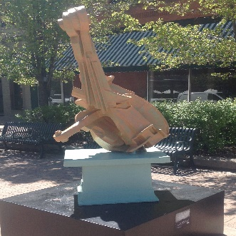 | CELLO - $5000  Dimensions: 56” X 41” X 29”  Materials: Epoxy Resin/Kevlar Cloth  Installation: Indoor/Outdoor
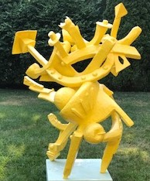 | CELEBRATION - $3500  Dimensions: 5’ X 4’ X 3.5’  Materials: Mixed Resins/Fiberglass Cloth  Installation: Indoor/Outdoor
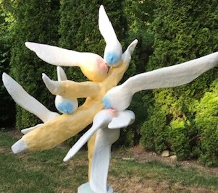 | MOON DANCE - $5000  Dimensions: 79” X 55” X 38”  Materials: Polyester Resin/Fiberglass  Installation: Indoor/Outdoor
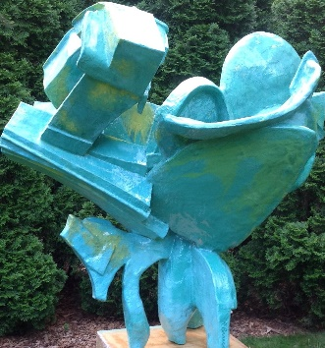 | ABSTRACT 29 - $4500  Dimensions: 52” X 55” X 37”  Materials: Epoxy Resin/Fiberglass Cloth  Installation: Indoor/Outdoor
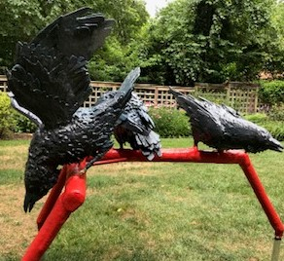 | CROWS – Not for Sale  Dimensions: 90” X 57” X 29”  Materials: PVC/ Mixed Resins  Installation: Indoor/Outdoor
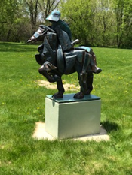 | WAR HORSE - $6000  Dimensions: 4.25’ X 4’ X 2’  Materials: Epoxy/Fiberglass  Installation: Indoor/Outdoor
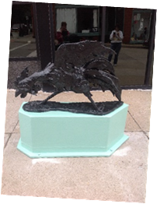 | FREE RANGE - $1500  Dimensions: 26” x 17” x 41”  Materials: Epoxy Resin/ Fiberglass Cloth  Installation: Indoor/Outdoor
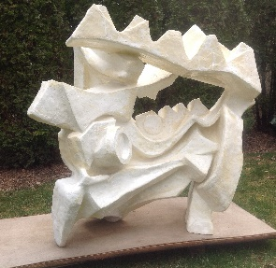 | RECTANGULAR ABSTRACT - $6000  Dimensions: 50” X 56” X 33”  Materials: Epoxy Resin/Fiberglass Cloth  Installation: Indoor/Outdoor
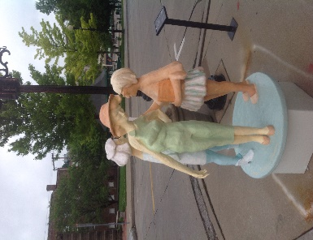 | THREE SISTERS - $4500  Dimensions: 63” X 36” X 36”  Materials: Epoxy Resin/Fiberglass  Installation: Indoor/Outdoor
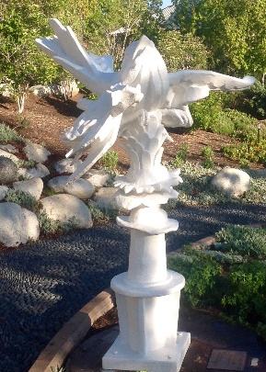 | SPARROW - $6000  Dimensions: 6’ X 5’ X 4’  Materials: Epoxy Resin/Fiberglass Cloth  Installation: Indoor/Outdoor

